**COMSATS UNIVERSITY ISLAMABAD LAHORE CAMPUS.**

**19-OCT-2025.**

**Dated:**

**(FA24-BBA-062).**

**Zia-UR-Rasool.**

**Submitted By:**

**Prof. Mufeeza Manzoor.**

**Submitted to:**

**Topic:**

**Python Programs.**

**Department Of Management Sciences.**

**COMSATS UNIVERSITY ISLAMABAD LAHORE CAMPUS.**

**Exercise 1:**

Make a list.

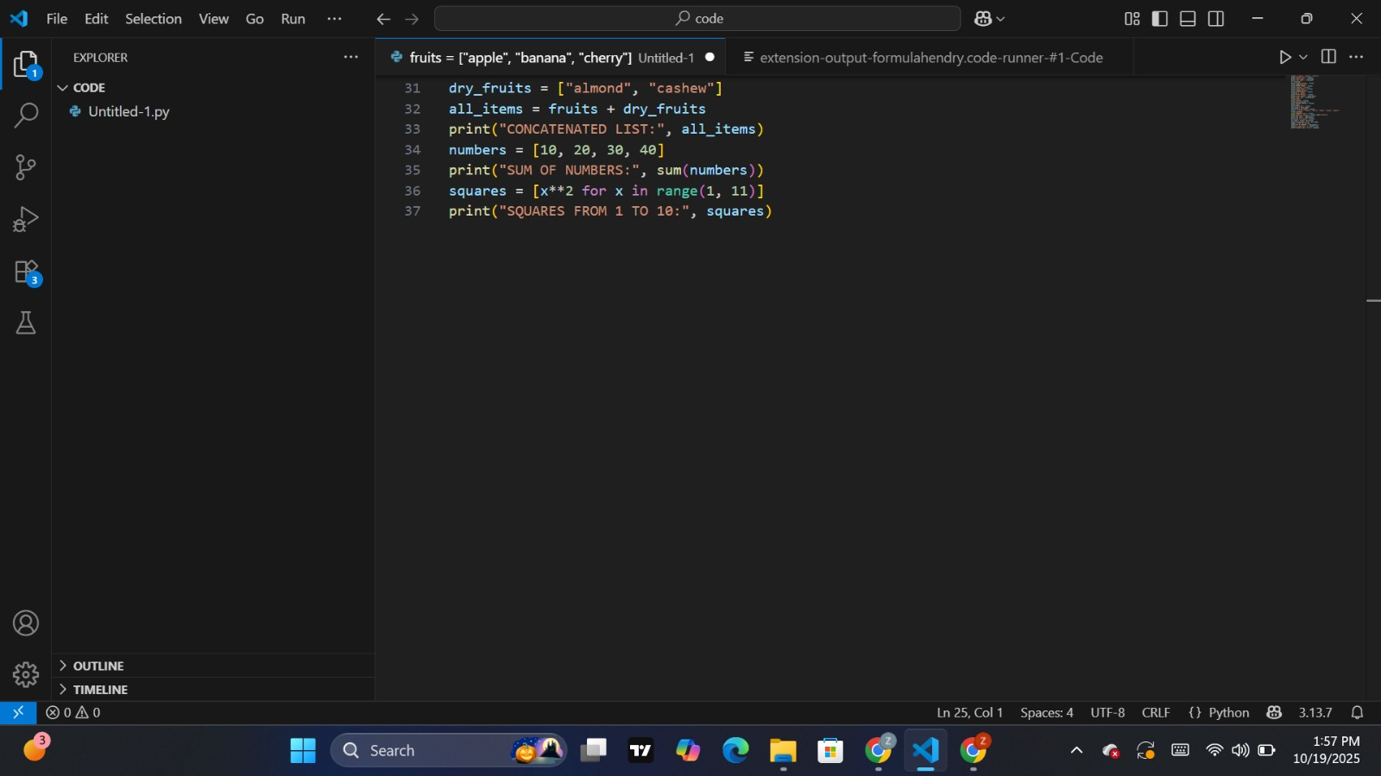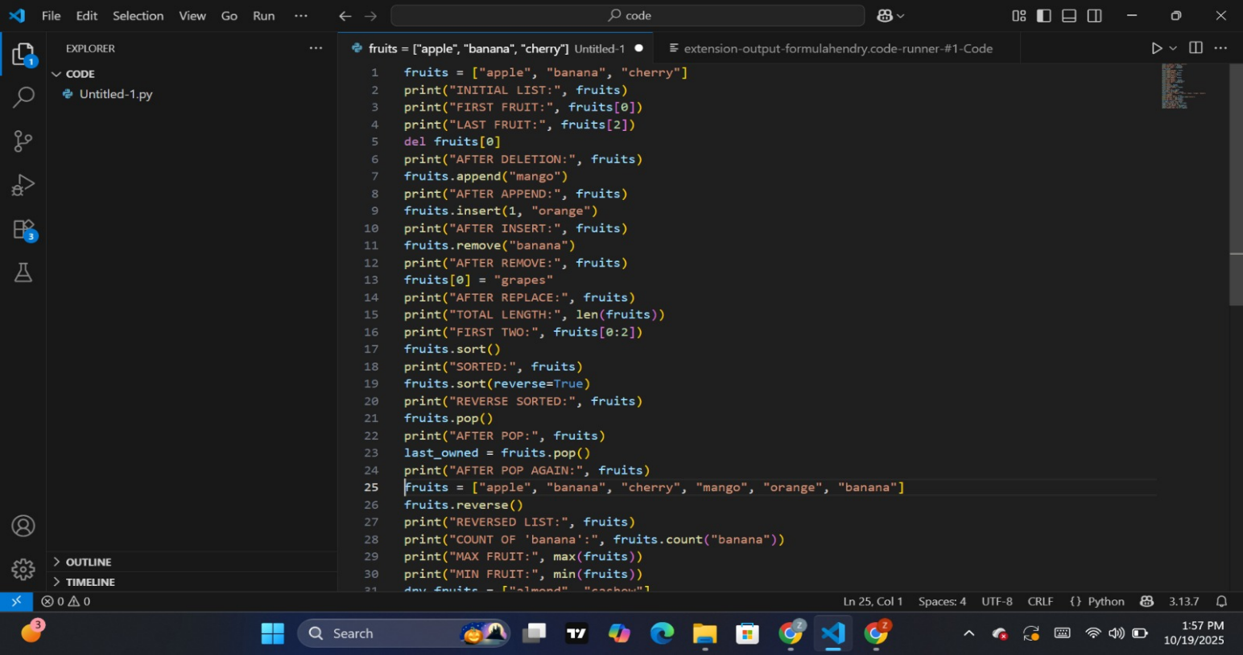**Program:**

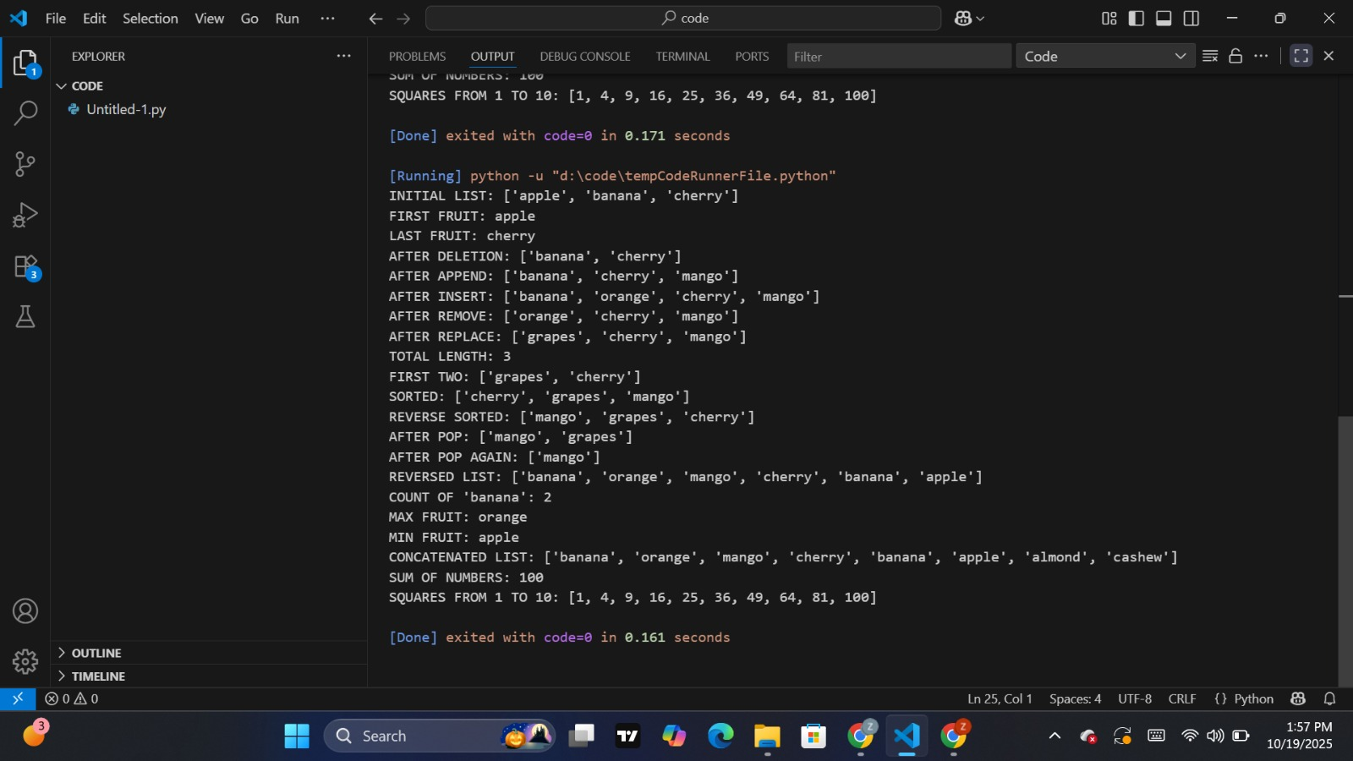**Output:**